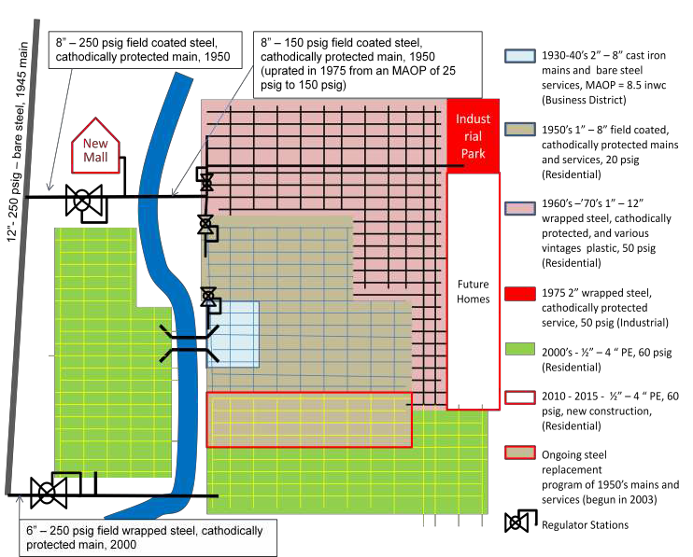
Figure 1- Mock Town Natural Gas System

1

System Description:
The Local Distribution Gas Company (LDC) first supplied Mock Town with manufactured gas in 1935. At that time, the distribution system served only the business district and consisted of 2–8 inch cast iron mains and bare steel services. The system operated at 7.8 INWC. In 1945 the LDC installed a 12”-250 psig bare steel main to serve the town. The town consisted of a downtown business district and about 1,000 residences. (System 1)
In 1950 Mock Town installed an eight inch steel main header and a regulator station to cut the pressure to 20 psig to serve the residences of the town and to decommission the plant. The heating value changed from 600 BTU (manufactured gas) to 1065 BTU (interstate pipeline supply). The LDC adjusted all the customer’s appliances as a part of the conversion. Over the next 10 years, the LDC installed mains and services to most of the existing residences. (System two)
In the 1960s and 1970s the company expanded the system to serve an additional 7,500, mostly residential, customers, mostly with 2–12 inch wrapped steel mains and services, ¾ – four inch mechanically joined steel mains and services, and various vintages of plastic pipe all operating at 20psig. The plastic mains and services were installed beginning in 1971. (System three)
In 1975 an industrial park was built at the west end of town. The industrial customers needed 30 psig to operate some of the equipment and to accommodate the large load at the far end of the system. The system in pink was separated from the section installed in the 1950s and updated to 50 psig. The industrial customer is served from this 50 psig system. (System three)
Through the 2000s the company served new developments at the south end of town through a new six inch– 250 psig header to a regulator station where the pressure is cut to 60 psig. (System four)

Due to past problems in a section of the 1950s mains, the company has started to replace the mains and services. They are inserting the mains and services with plastic pipe. (System five)
The next planned growth area is at the west side of town and will be served from the existing 60 psig system and a new mall west of the river. (System six)

The higher pressure, distribution feeder lines are grouped together. (System seven) The regulator stations were grouped together. (System eight)
There are currently 20,000 commercial and residential customers and one industrial park.

Subsystems and operating problem summary:
Subsystem one - 1930–1940s, low-pressure, 30 miles of 4–8 inch cast iron system serving the business district.The system occasionally takes in water when the river floods the business area. No pipe has been replaced. (1,000 Commercial and residential services – all bare steel). The local water utility experiences a large number of water main breaks during the first freezes in the fall.
Subsystem two – 1950s, 20 psig, 210 miles of 3/4 – eight inch field coated, cathodically protected mains and services (4,500 Residential services). This area experienced a lot of third party damage when fiber optic was being installed in the 2000s.
Subsystem three – 1960s –1970s, 50 psig, 375 miles of one – 12 inch wrapped steel, cathodically protected, 20 miles of various vintage plastic pipe, (7,500 Residential services) and five miles of 1975 2 inch wrapped steel, mechanically joined, cathodically protected service, (industrial). Uprated in 1975 from 25 psig MAOP to 55 psig MAOP. MOP of 50 psig.
Subsystem four - 2000s 60 psig, 410 miles of ½– 4 inch PE (6,000 residential services). Fiber optic is scheduled to be installed next year in this area.
Subsystem five – Ongoing steel replacement program of 1950s, 20 psig, 80 miles of 3/4 – 8 inch field coated, cathodically protected mains and services (began in 2003 – 1,500 residential services: replaced to date 10 miles of main and 300 services). The number of leaks on this system has been rising at an increasing rate.
Subsystem six– (Future) 60 psig, 100 miles of ½– 4 inch PE, new construction (5,000 residential services). All utilities will be installed utilizing a joint trench.
Subsystem seven– 10 miles of 12 inch- 250 psig bare steel 1945 main, one mile of eight inch-250 psig coated 1950 steel main, two miles of eight inch coated steel main installed in 1950 and uprated in 1975 from 25 psig to 150 psig, and two miles of six inch-250 psig was installed in 2000 main (no services).
Subsystem eight – Total of 15 regulator stations – several low pressure regulator stations are in vaults and get filled with water when the river floods. Replacement parts are getting more difficult to find for several models in service. The new system will have only one feed. The regulator feeding the north end of the system has had some freezing problems during periods of peak loads. No customers were lost but since the station does not have SCADA connected to gas control, the regulators require a crew to inspect the station frequently during cold weather. The remaining stations have SCADA (no services).

