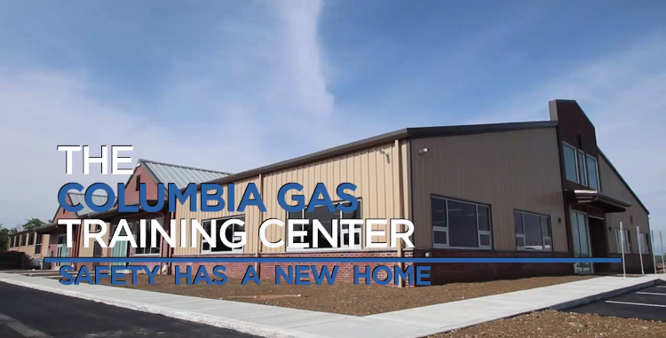

DIRECTIONS
The address for the Training Center, is 1600 Eastgate Parkway Gahanna, OH 43230. Written directions are outlined below in case the address is not recognized by GPS.

Directions from I-670 E/US-62 E, I-270 S and Taylor Rd to Eastgate Pkwy – Take Exit 7 - Head southwest on I-670 W. Take exit 7 for 5th Ave toward US-62. Turn left onto US-62 E/E 5th Ave. Turn left onto the Interstate 670 E/US 62 E ramp to Airport. Merge onto I-670 E/US-62 E. Use the right 2 lanes to take the Interstate 270 S exit toward Wheeling. Merge onto I-270 S. Take exit 37 for OH-317/Hamilton Rd. Use the left 2 lanes to turn left onto OH-317 N/S Hamilton Rd. Turn right onto Morrison Rd/Rocky Fork Dr S. Continue to follow Morrison Rd. Turn left onto Taylor Rd. Turn right onto Eastgate Pkwy. Destination will be on the right.
Directions from I-670 W and Exit 9 to International Gateway in Columbus – Take exit 9 from I-670 W. - Head southwest on I-670 W. Use the right 2 lanes to take exit 9 toward Stelzer Rd/Airport. Keep left at the fork, follow signs for Port Columbus International Airport. Follow International Gateway and Sawyer Rd to S Hamilton Rd. Continue onto International Gateway. Slight left toward International Gateway. Slight left onto International Gateway. Turn right onto Sawyer Rd (signs for Sawyer Road). Turn right to stay on Sawyer Rd. Turn left at the 1st cross street onto S Hamilton Rd. Turn right onto Tech Center Dr. Take Taylor Rd to Eastgate Pkwy. Turn left onto Morrison Rd. Turn right onto Taylor Rd. Turn right onto Eastgate Pkwy. Destination will be on the right.
Directions from I-670 W and I-270 S to OH-317 N/S Hamilton Rd in Gahanna – Take Exit 37 from I-270 S. - Head northwest on I-670 W. Use the right 2 lanes to take exit 3 to merge onto W Goodale St toward Neil Ave. Use the left lane to turn left onto Neil Ave. Turn left onto Spruce St. Take the Interstate 670 E ramp on the left. Merge onto I-670 E. Keep left to stay on I-670 E. Use the right 2 lanes to take the Interstate 270 S exit toward Wheeling. Merge onto I-270 S. Take exit 37 for OH-317/Hamilton Rd. Take Taylor Rd to Eastgate Pkwy. Use the left 2 lanes to turn left onto OH-317 N/S Hamilton Rd. Turn right onto Morrison Rd/Rocky Fork Dr S. Turn left onto Taylor Rd. Turn right onto Eastgate Pkwy. Destination will be on the right.

Please enter through the front entrance of the training building.

HOTEL ACCOMMODATIONS
There are several hotels within a mile of the Training Facility. The Holiday Inn Express & Suites Gahanna or the Springhill Suites by Marriott Columbus Airport Gahanna are two of the options we suggest.

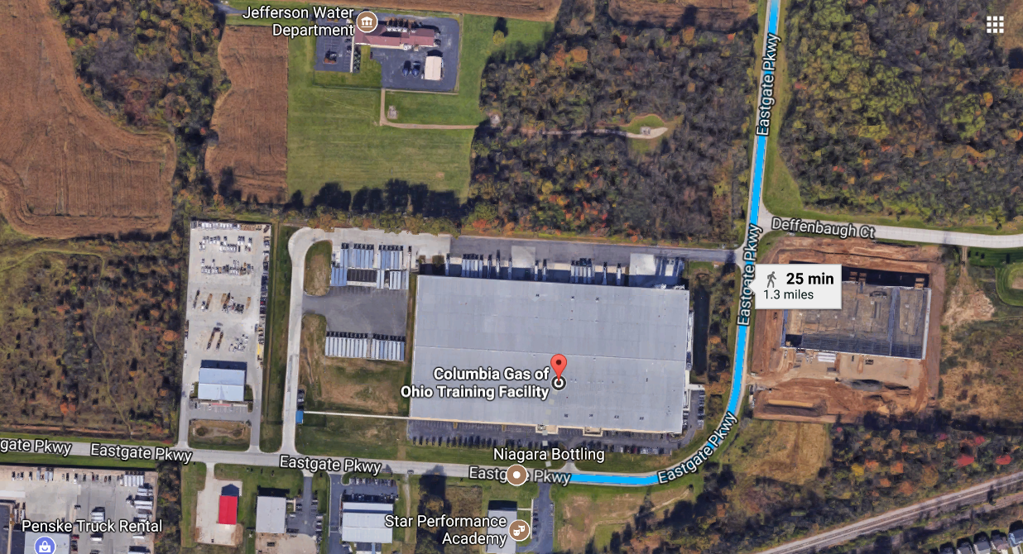

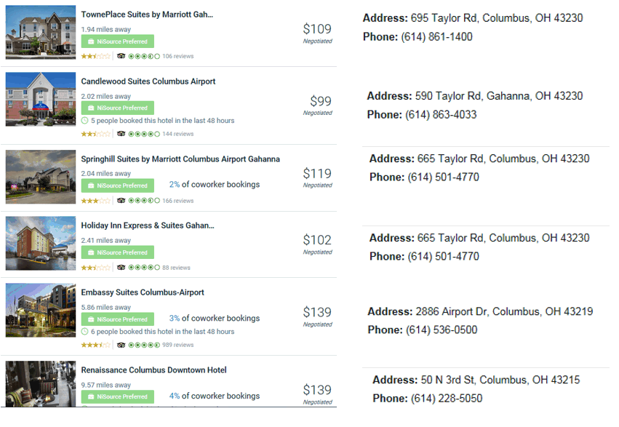
CATERING LIST:
Nazareth 5239 N Hamilton Rd, Columbus, OH 43230
Menu:
http://www.https://www.google.com/url?sa=t&rct=j&url=http%3A%2F%2Fnazarethdeli.com%2F&source=maps&cd=1&usg=AFQjCNGZ8hI4p9YrfroEF7UezWDEumZiqA&ved=1i%3A1%2Ct%3A3443%2Ce%3A0%2Cp%3A7oyAWY7jNoq9jwSb8IKABQ%3A115
Phone number: 614-899-1177
The Barn at Rocky Fork Creek 1370 E Johnstown Rd, Gahanna, OH 43230
Menu:
https://www.google.com/url?sa=t&rct=j&url=http%3A%2F%2Fwww.thebarncolumbus.com%2F&source=maps&cd=1&usg=AFQjCNFcqHdukoCMROzOWVfTZklwDqtQiQ&ved=1i%3A1%2Ct%3A3443%2Ce%3A0%2Cp%3A7oyAWY7jNoq9jwSb8IKABQ%3A298
Phone number: 614-855-9840
Moe’s Southwest Grill 363 S Hamilton Rd, Gahanna, OH 43230
Menu:
https://www.google.com/url?sa=t&rct=j&url=http%3A%2F%2Fwww.moes.com%2Ffind-a-moes%2Fohio%2Fgahanna%2F4831%2F%3Futm_source%3Dgoogle%26utm_medium%3Dorganic%26utm_campaign%3Dlocalmaps&source=maps&cd=1&usg=AFQjCNFY99_BWKqoLaC1h9h9NRtfKKgbhA&ved=1i%3A1%2Ct%3A3443%2Ce%3A0%2Cp%3A7oyAWY7jNoq9jwSb8IKABQ%3A479
Phone number: 614-934-7600
Olive Garden Italian Restaurant 4860 N Hamilton Rd, Columbus, OH 43230
Menu: https://www.google.com/url?sa=t&rct=j&url=http%3A%2F%2Fwww.olivegarden.com%2Flocations%2Foh%2Fcolumbus%2Fcolumbus-n-hamilton-rd%2F1820%3Fcmpid%3Dbr%3Aog_ag%3Aie_ch%3Adry_ca%3AOGGMB_dt%3Aong_sn%3Agmb_gt%3Acolumbus-oh-1820_pl%3Alocurl_rd%3A1428&source=maps&cd=1&usg=AFQjCNEV17mRouQ4GG5yWBnfduDx8CcjOw&ved=1i%3A1%2Ct%3A3443%2Ce%3A0%2Cp%3A7oyAWY7jNoq9jwSb8IKABQ%3A566
Phone number: 614-855-4761
Rusty Bucket Restaurant & Tavern 73 N Hamilton Rd, Gahanna, OH 43230
Menu: https://www.google.com/url?sa=t&rct=j&url=http%3A%2F%2Fwww.myrustybucket.com%2Feaston&source=maps&cd=1&usg=AFQjCNG_ClwHZjvtDAlncYAPIxHuEHyotQ&ved=1i%3A1%2Ct%3A3443%2Ce%3A0%2Cp%3A7oyAWY7jNoq9jwSb8IKABQ%3A655
Phone number: 614-475-4435

Bob Evans 443 Morrison Rd, Columbus, OH 43230
Menu: https://www.google.com/url?sa=t&rct=j&url=https%3A%2F%2Fwww.bobevans.com%2Four-restaurants%2Flocations%2F26&source=maps&cd=1&usg=AFQjCNEuYrtHI1WB5lkmbr6YVuThgz_hsw&ved=1i%3A1%2Ct%3A3443%2Ce%3A0%2Cp%3A7oyAWY7jNoq9jwSb8IKABQ%3A744
Phone number: 614-475-4141
Chipotle Mexican Grill 95 N Hamilton Rd, Gahanna, OH 43230
Menu: https://www.google.com/url?sa=t&rct=j&url=http%3A%2F%2Fwww.chipotle.com%2F&source=maps&cd=1&usg=AFQjCNHLpknkLtPYoKNVLmZcqalHK3MRIg&ved=1i%3A1%2Ct%3A3443%2Ce%3A0%2Cp%3A7oyAWY7jNoq9jwSb8IKABQ%3A831
Phone number: 614-472-4080
Texas de Brazil 4040 Easton Station e, Columbus, OH 43219
Menu: https://www.google.com/url?sa=t&rct=j&url=http%3A%2F%2Fwww.texasdebrazil.com%2Flocations%2Fohio%2Fcolumbus%2F&source=maps&cd=1&usg=AFQjCNEuHADRytZJsRxR3Ev1EaU_YQZucQ&ved=1i%3A1%2Ct%3A3443%2Ce%3A0%2Cp%3A7oyAWY7jNoq9jwSb8IKABQ%3A920
Phone number: 614-472-4072
Max & Erma’s 1317 N Hamilton Rd, Gahanna, OH 43230
Menu: https://www.google.com/url?sa=t&rct=j&url=http%3A%2F%2Fwww.maxandermas.com%2F&source=maps&cd=1&usg=AFQjCNEu-xkwHRdfHCs7YsDaMJchRm4icA&ved=1i%3A1%2Ct%3A3443%2Ce%3A0%2Cp%3A7oyAWY7jNoq9jwSb8IKABQ%3A1011
Phone number: 614-471-0009
Raising Cane’s Chicken Fingers 1320 N Hamilton Rd, Gahanna, OH 43230
Menu: https://www.google.com/url?sa=t&rct=j&url=http%3A%2F%2Fwww.raisingcanes.com%2F&source=maps&cd=1&usg=AFQjCNGHPA8KUf2JEiktzXw50nRp4S_ufg&ved=1i%3A1%2Ct%3A3443%2Ce%3A0%2Cp%3A7oyAWY7jNoq9jwSb8IKABQ%3A1100
Phone number: 614-475-1300
Smashburger 109 N Hamilton Rd, Columbus, OH 43230
Menu: https://www.google.com/url?sa=t&rct=j&url=http%3A%2F%2Flocations.smashburger.com%2Fus%2Foh%2Fgahanna%2F1557%3Futm_source%3Dgoogle%26utm_medium%3Ddistrib%26utm_campaign%3Dgoogle-distrib&source=maps&cd=1&usg=AFQjCNF2-dQ1E-8dbZB1GnL5fcYK6E_KqA&ved=1i%3A1%2Ct%3A3443%2Ce%3A0%2Cp%3A7oyAWY7jNoq9jwSb8IKABQ%3A1189
Phone number: 614-721-6400
Chick- Fil- A 6240 E Broad St, Columbus, OH 43213
Menu: https://www.google.com/url?sa=t&rct=j&url=http%3A%2F%2Fwww.chick-fil-a.com%2Fmarketateastbroad&source=maps&cd=1&usg=AFQjCNFTU1cTf3hQmuAJ4dnzGhyboE3NTg&ved=1i%3A1%2Ct%3A3443%2Ce%3A0%2Cp%3A7oyAWY7jNoq9jwSb8IKABQ%3A3357
Phone number: 614-861-2300
El Vaquero 373 Stoneridge Ln, Gahanna, OH 43230
Menu: https://www.google.com/url?sa=t&rct=j&url=http%3A%2F%2Fwww.vaquerorestaurant.com%2F&source=maps&cd=1&usg=AFQjCNFLnBySMpJq5ZjWcK1wi23fRpkP-Q&ved=1i%3A1%2Ct%3A3443%2Ce%3A0%2Cp%3A7oyAWY7jNoq9jwSb8IKABQ%3A1492
Phone number: 614-428-1725
Chuy’s 4154 Seward St, Columbus, OH 43219
Menu: https://www.google.com/url?sa=t&rct=j&url=http%3A%2F%2Fchuys.com%2F&source=maps&cd=1&usg=AFQjCNGjCKc6iUgIjqEN0Dnwfic5xtq5Kw&ved=1i%3A1%2Ct%3A3443%2Ce%3A0%2Cp%3A7oyAWY7jNoq9jwSb8IKABQ%3A1581
Phone number: 614-498-0285

Room Layouts
On the following page is each room and how they are setup. If you would like to change the rooms setup you may, however that is for you to coordinate before your meetings. If you order lunch for your meeting on your own, it will be delivered to whatever room your meeting is held.
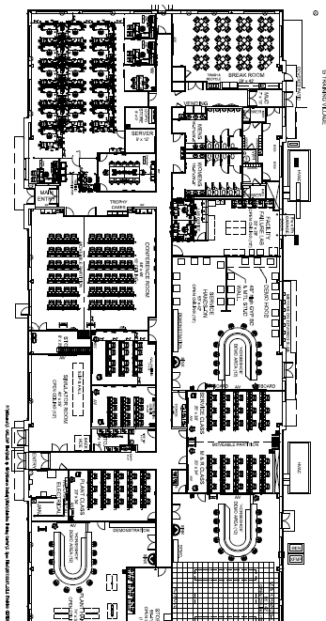
On the preceding page is a map of which room is which.

